ExchangeRate API

💱 What Is the ExchangeRate API?
# Source: AI Source: Provided by: [Data Path: Persons Table -> ID Column: 1, Name_En Column: Motasem Essam] -> From: [ChatGPT] on [1/19/2026]
The ExchangeRate API (also called Currency Exchange API or Forex API) is a web service that provides real-time or historical currency exchange rates between different world currencies.
It allows applications to automatically convert money, track currency values, or display up-to-date prices in different currencies.

✅ Simple Definition:
# Source: AI Source: Provided by: [Data Path: Persons Table -> ID Column: 1, Name_En Column: Motasem Essam] -> From: [ChatGPT] on [1/19/2026]
An ExchangeRate API gives the latest or past currency values (like USD → EUR), so apps can show accurate prices or perform money conversions.

🌍 Example Use Cases:
# Source: AI Source: Provided by: [Data Path: Persons Table -> ID Column: 1, Name_En Column: Motasem Essam] -> From: [ChatGPT] on [1/19/2026]
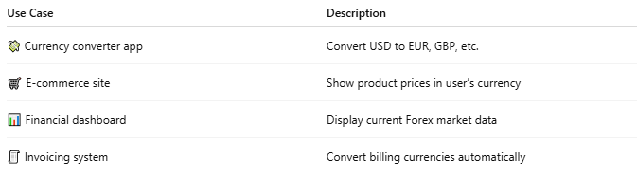

Use Case | Description
💸 Currency converter app | Convert USD to EUR, GBP, etc.
🛒 E-commerce site | Show product prices in user’s currency
📊 Financial dashboard | Display current Forex market data
🧾 Invoicing system | Convert billing currencies automatically

🧪 Sample Exchange Rate API Request
# Source: AI Source: Provided by: [Data Path: Persons Table -> ID Column: 1, Name_En Column: Motasem Essam] -> From: [ChatGPT] on [1/19/2026]
Using a free provider like exchangerate.host:
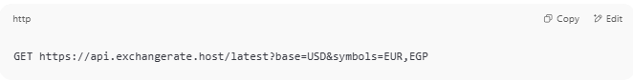
GET https://api.exchangerate.host/latest?base=USD&symbols=EUR,EGP

🔁 Response:
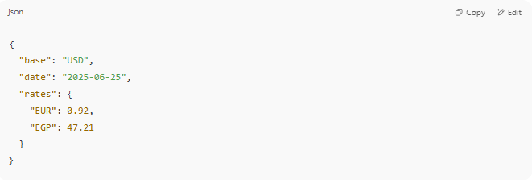
{
"base": "USD",
"date": "2025-06-25",
"rates": {
"EUR": 0.92,
"EGP": 47.21
}
}

📦 Common Parameters
# Source: AI Source: Provided by: [Data Path: Persons Table -> ID Column: 1, Name_En Column: Motasem Essam] -> From: [ChatGPT] on [1/19/2026]
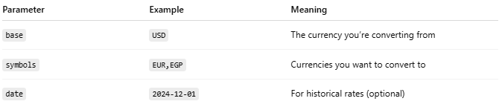

Parameter | Example | Meaning
base | USD | The currency you’re converting from
symbols | EUR,EGP | Currencies you want to convert to
date | 2024-12-01 | For historical rates (optional)

📊 Top Exchange Rate APIs (Free & Paid)
# Source: AI Source: Provided by: [Data Path: Persons Table -> ID Column: 1, Name_En Column: Motasem Essam] -> From: [ChatGPT] on [1/19/2026]
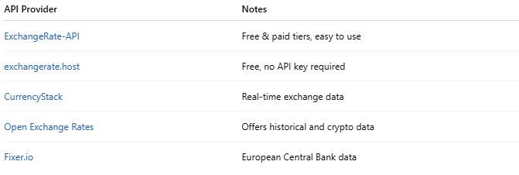

API Provider | Notes
ExchangeRate-API | Free & paid tiers, easy to use
exchangerate.host | Free, no API key required
CurrencyStack | Real-time exchange data
Open Exchange Rates | Offers historical and crypto data
Fixer.io | European Central Bank data

🧰 PHP Example Using file_get_contents
# Source: AI Source: Provided by: [Data Path: Persons Table -> ID Column: 1, Name_En Column: Motasem Essam] -> From: [ChatGPT] on [1/19/2026]
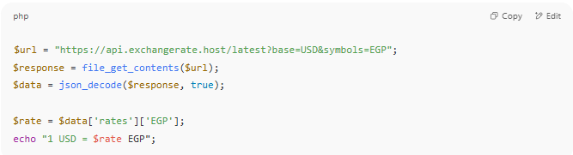

$url = "https://api.exchangerate.host/latest?base=USD&symbols=EGP";
$response = file_get_contents($url);
$data = json_decode($response, true);

$rate = $data['rates']['EGP'];
echo "1 USD = $rate EGP";

🔐 Do You Need an API Key?
# Source: AI Source: Provided by: [Data Path: Persons Table -> ID Column: 1, Name_En Column: Motasem Essam] -> From: [ChatGPT] on [1/19/2026]
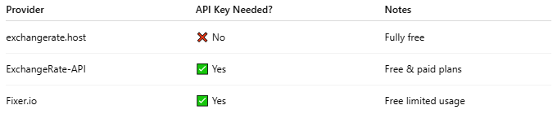

Provider | API Key Needed? | Notes
exchangerate.host | ❌ No | Fully free
ExchangeRate-API | ✅ Yes | Free & paid plans
Fixer.io | ✅ Yes | Free limited usage

⚠️ Limitations to Watch For
# Source: AI Source: Provided by: [Data Path: Persons Table -> ID Column: 1, Name_En Column: Motasem Essam] -> From: [ChatGPT] on [1/19/2026]
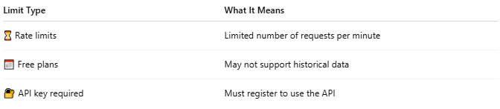

Limit Type | What It Means
⏳ Rate limits | Limited number of requests per minute
📅 Free plans | May not support historical data
🔐 API key required | Must register to use the API

